J:\subory\Emilove\studium\FP2\2020-21\sken\FP2mgr17.tif

J:\subory\Emilove\studium\FP2\2020-21\sken\FP2mgr18.tif

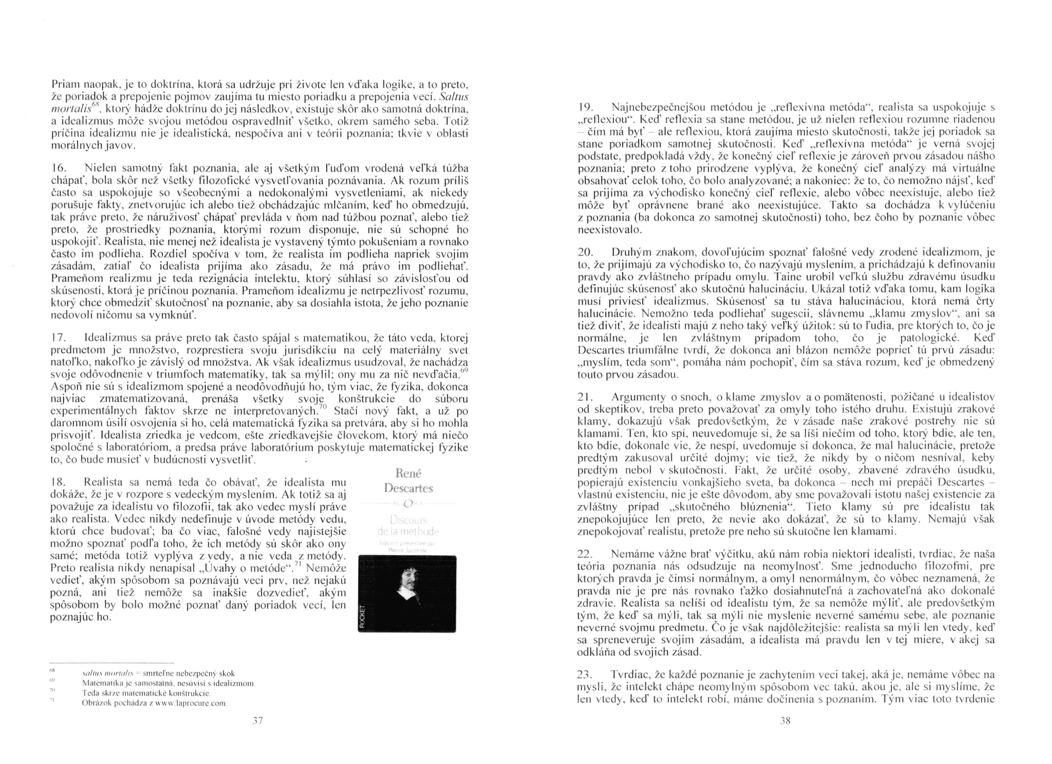

J:\subory\Emilove\studium\FP2\2020-21\sken\FP2mgr20.tif